Proposed Drws Cefn Gate Design
Draft v0.1 - Prepared by Alastair Garman on behalf of PDCMG – June 2016
Design criteria
It is highly likely that any gate preventing access to Drws Cefn will be vandalised. Therefore the two approaches are a substantial engineering project that will resist vandalism or a cheap and easy solution that controls access, but with minimal cost & effort implications.
The gate must allow access under agreed circumstances, eg. cave rescue.
Location
At the bottom of the excavated surface shaft is a flat out crawl, around 10m in length. About 5m into this crawl is a point that has already been widened and it would be feasible to install a scaffolded bar across the middle of the passage, to control access.
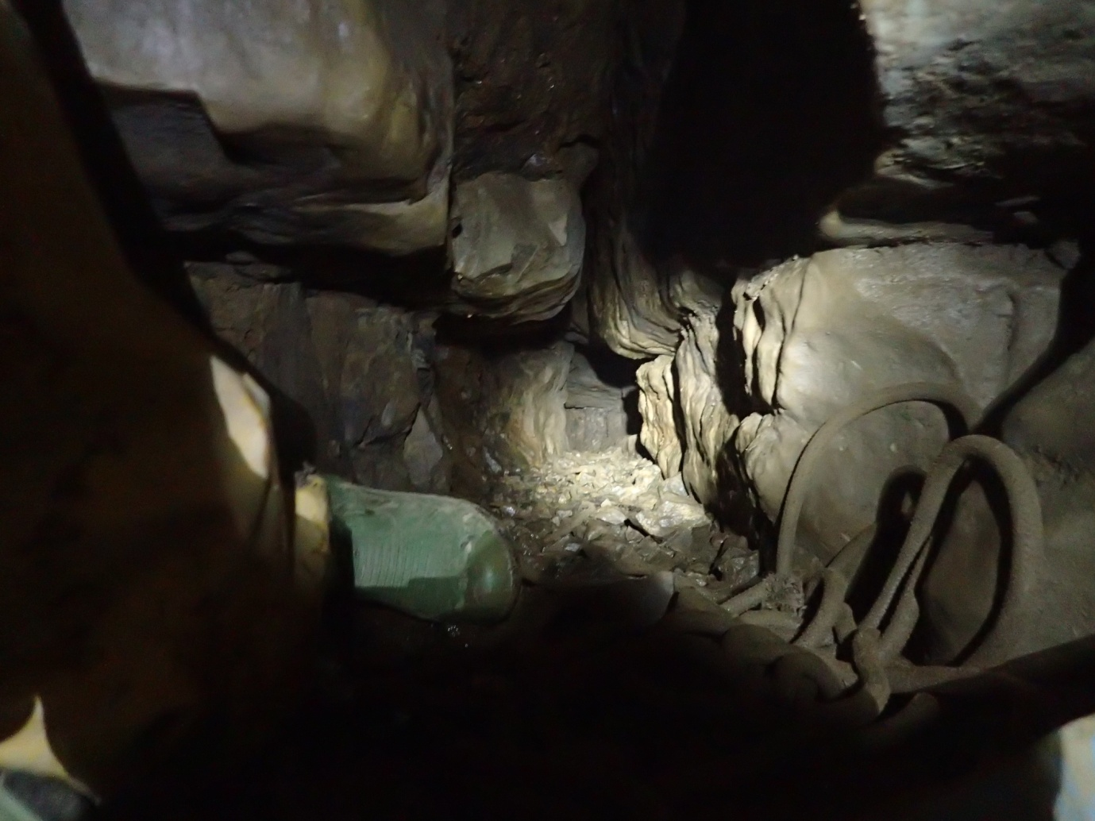
View looking into the crawl, travelling into the cave.

Proposed Design
Below is schematic of the proposed design. :-
- The blue bars are scaffolding bars :-
  - One permanently fixed at floor level to prevent digging under the removable scaffolding bar
  - A second removable horizontally bar across the centre of the passage, suspended by metal brackets at either end.
- The metal brackets (pink) will be bolted and concreted in place, at either end of the removable centre scaffolding bar.
- A padlock will secure one end of the removable scaffolded bar and allow access. A number of locking approaches are possible, but the exact choice does not affect the bat licence.
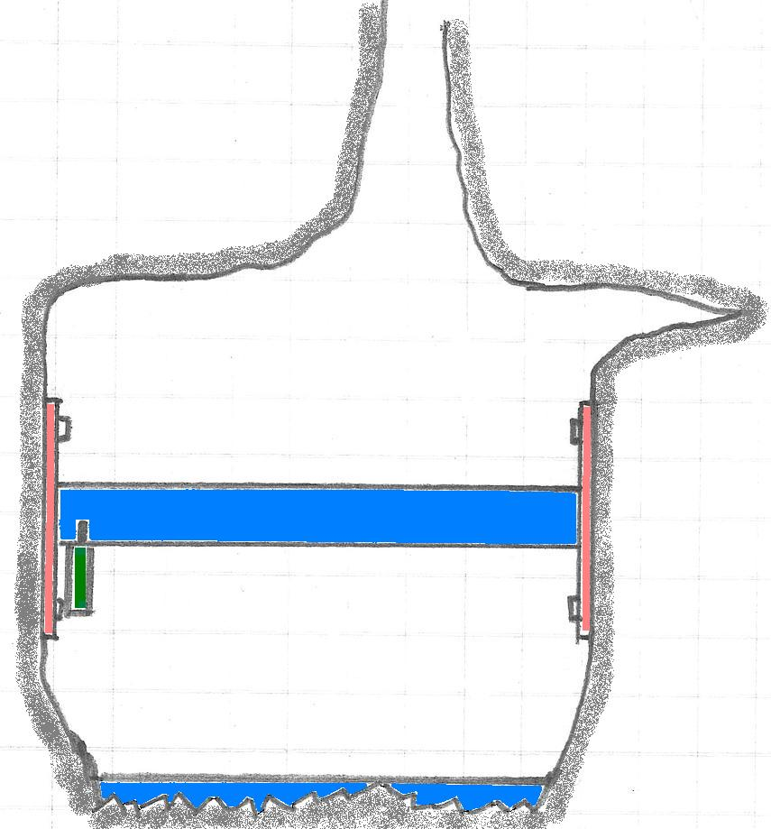
Note: Looking inwards into the cave
Dimensions
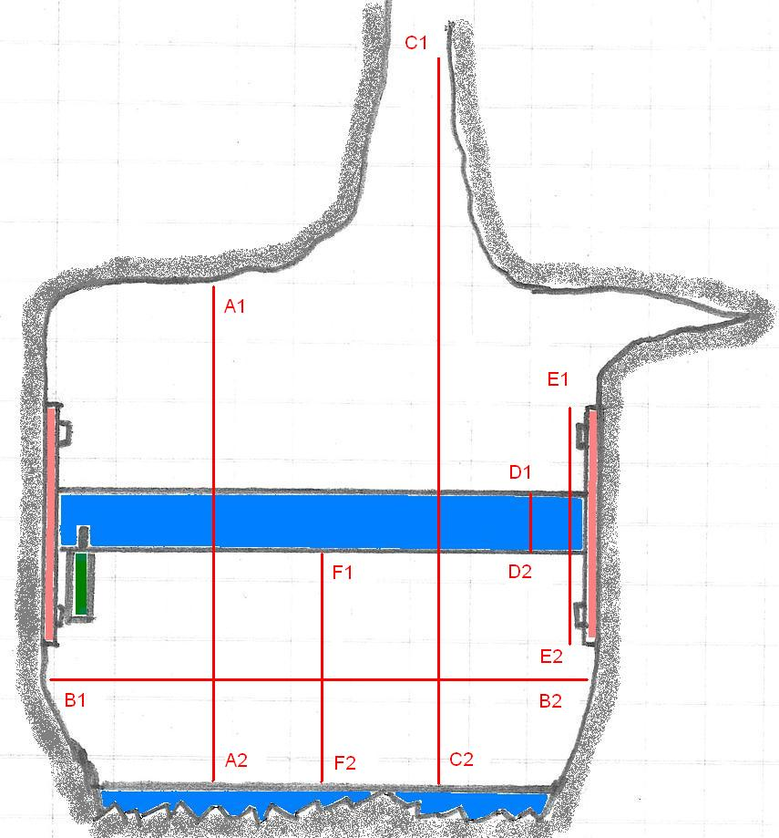
A1 – A2 = 40cm
B1 – B2 = 45cm
C1 – C2 = 180cm (the narrow vertical slot continues above C1)
D1 – D2 = Standard UK scaffolding bar (5cm)
E1 – E2 = 20cm square bracket with 4 corner bolts
F1 – F2 = 20cm (although exact size is easily changeable at the point of installation)

Features of the Design
- Essentially the gate consists of a single horizontal scaffolding bar and therefore has no impact on airflow.
- The scaffolded bar embedded in the floor prevents digging underneath the main removable bar.
- The gate provides two large bat opening, above and below the main removable bar.
- The exact vertical positioning of the removable horizontal bar is adjustable, as part of the licence agreement process.
- The gap between the two scaffolding bars (lower opening) will be 20cm high and > 40cm wide [See note below about aperture size].
- The central bar can be removed by opening the padlock with a key.
- Alcoves on either side passage walls will need to be filled / flattened with concrete to provide a flat surface to bolt the supporting brackets to.
- The brackets are required to firmly hold the scaffolding bar in exactly the right vertical position, thereby maintaining the dimensions of the bat opening.
- The location of the gate is in one of the wider sections of the crawl, ie. the bat’s flight is much more constricted elsewhere in the entrance series.
Risks
The gap between the two horizontal scaffolding bars is dangerously close to the size through which a determined caver could squeeze. We understand that the required bat aperture is 40cm wide by 20cm high. A caver getting stuck between rib cage and pelvis, could be in a perilous position and require rescueing.
Reduce the height of the aperture by as little as 2cm, would make the gate much safer. Would this be possible? Note that there is a similar sized second aperture above the main bar.
There is a history of vandalism affecting entrances to Ogof Draenen. It is likely that this gate will similarly be vandalised at some point.

Photos
These photos are to help a non-caver understand the confines of the cave and visualise what is being proposed.
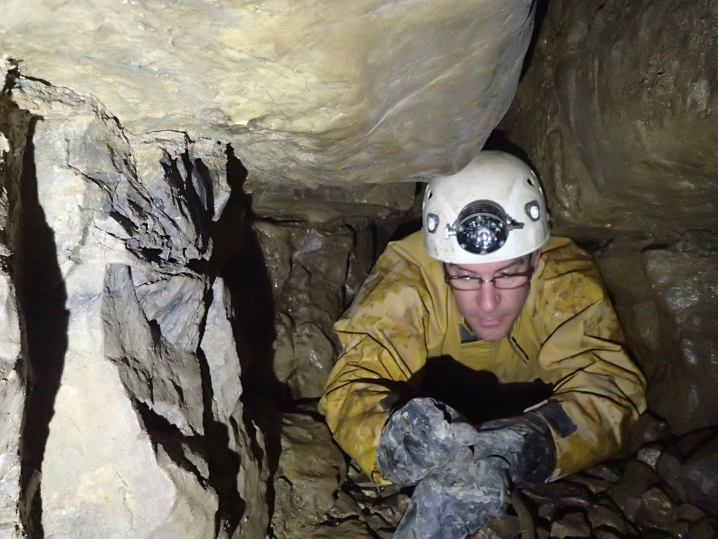
The photo is looking into the cave. The removeable scaffolding bar will be across the passage at about nose height. The permenantly fixed scaffolding bar will be embedded in the gravel floor.
Note the distinctive shot hole on the left of this photo. This shows that a significant portion of the left handwall has been removed. This photo is to prove that these alterations were not undertaken by the PDCMG. I would further add that I do not believe this blasting had taken place when I last visited Drws Cefn in 2010, as part of preparing the previous bat licence application.
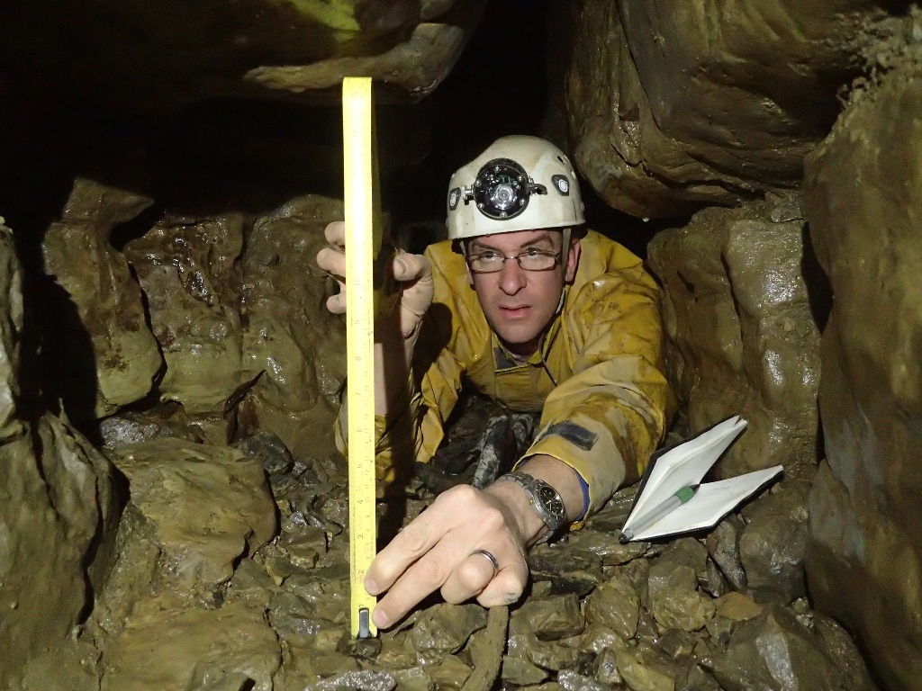
The full resolution copy of this image shows that the tape measure reads 40cm, but I have reduced the image quality to reduce the file size of this document. Originals obviously available on request.
Looking into the cave. Note the alcoves on either side of the passage, these will require some concreting and bolting, to support the brackets.
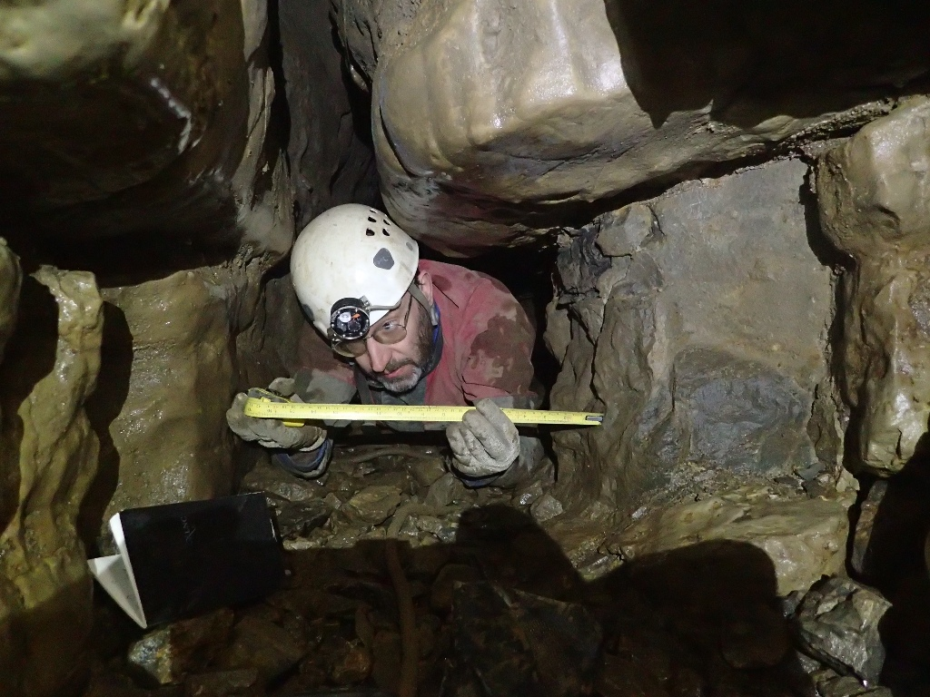
Looking out of the cave. Again higher resolution images show a width of 45cm.

